Service Description (SD) – Energy Forecast

**Abstract**

This document defines the template for the Service Description of Arrowhead compliant Services.

A Service Description provides an an abstract description of what is needed for systems/devices/units/software to provide and/or consume a specific service.

SD’s for Application Services are created (specified) by the Pilots WP’s and by the common Arrowhead framework. The SD shall make it possible for an engineer with technical programming knowledge to achieve an Arrowhead compliant realization of a provider and/or consumer of description of how the service is implemented/realized by using the Communication Profile and the chosen technologies.

A Service Description (SD) is the Service in a specific technology. All systems/devices/units/software implementing an Interface Design Description which complies with this SD will be able to exchange information with each other.

All Arrowhead Service Description should be specified using this template and stored on a common repository (available on the SVN server), in order to document and formalize the pilot demonstrators and the common Arrowhead framework.

Table of contents

No table of contents entries found.

1. Service Description Overview

This service provides energy forecasts.

1. Abstract Interfaces

Example use of the energy forecast service:

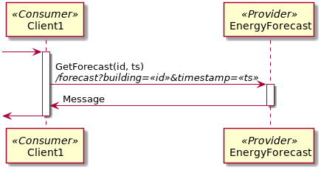

1. Abstract Information Model

The output of the service is a Message:

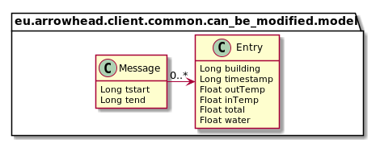

Table 1 Data type description

|  |  |
| --- | --- |
| **Field** | **Description** |
| Tstart | Timestamp of the earliest entry in the list |
| Tend | Timestamp of the latest entry in the list |
| Building | ID of the building |
| Timestamp | Time of the forecast entry |
| OutTemp | Predicted outside temperature |
| InTemp | Not used in energy forecasts |
| Total | Predicted total amount of energy required |
| Water | Predicted amount required for heating water only |

1. Non-functional Requirements

The service has none non-functional requirements.

1. Revision history

# Amendments

|  |  |  |  |  |
| --- | --- | --- | --- | --- |
| No. | Date | Version | Subject of Amendments | Author |
| 1 | 2017-09-20 | 0.1 | First draft | Thomas Pedersen |
| 2 | 2017-12-12 | 0.2 | Updated, according to Jerker’s comments. | Thomas Pedersen |
| 3 | 2018-05-29 | 0.3 | Updated to learning algorithm. | Thomas Pedersen |
| 4 | 2018-08-20 | 0.4 | Updated to Arrowhead 4.0 | Thomas Pedersen |

# Quality Assurance

|  |  |  |  |
| --- | --- | --- | --- |
| No. | Date | Version | Approved by |
| 1 |  |  |  |